MANUAL TEST EXECUTION REPORT
Module Name : Login & Search Module – Myntra
Test Case ID: TC_001
Tester Name : Riya Dhariwal
Test Case Description: To verify the functionality of the Login and Search modules by executing manual test cases with valid and invalid inputs.
Prerequisites:
- Stable internet connection
- Google Chrome browser
- Valid Myntra website URL
- Valid test user credentials
Environment Information
- OS: Android 11
- Browser: Google Chrome
- Website: https://www.myntra.com

Test Cases
Scenario ID | Scenario | Expected Result | Actual Result | Status
1A | Login with valid credentials | User logs in successfully | Login successful | Pass
1B | Login with invalid password | Error message displayed | Error displayed | Pass
1c | Login with empty fields | Validation message displayed | Validation shown | Pass
2A | Search for "Shoes” | Relevant products displayed | Products displayed | Pass
2B | Search with blank input | Validation/No results | No results shown | Pass
2C | Search for invalid keyword | No matching products | No products found | Pass

Screenshots:
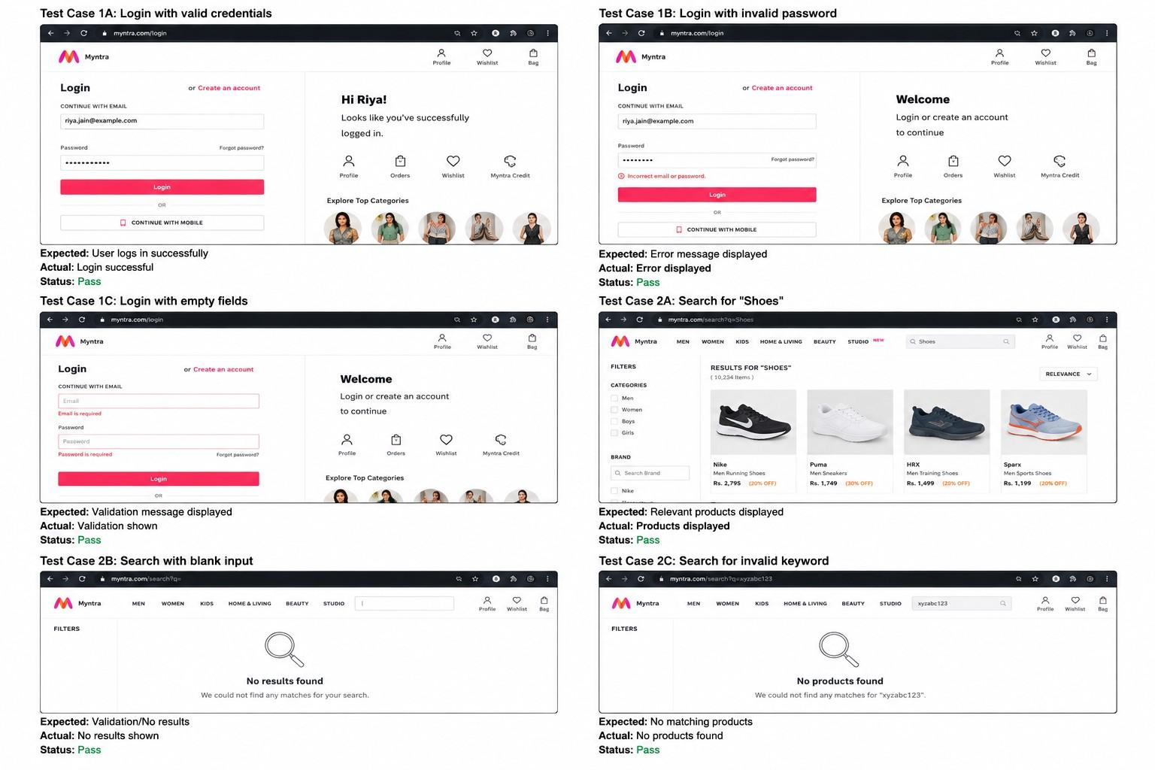

TEST EXECUTION SUMMARY
- Total Test Cases : 6
- Passed : 6
- Failed : 0
- Pass Percentage :100%
OBSERVATIONS
- Login works correctly with valid credentials.
- Invalid login attempts display appropriate error messages.
- Search functionality returns relevant products.
- Blank searches are handled properly.
- Website is responsive and user-friendly.

CONCLUSION
Manual testing was successfully completed, and all executed test cases passed as expected

